**Nile Delta Site: Sakha**

**The site**: Sakha Agricultural Research Station, Agricultural Research Center, Kafr El-Sheikh governorate, Egypt. It is located at 31°-07N latitude, 30°-57E longitude, with an elevation of about 6 meters above mean sea level, within the Governorate of Kafr el-Sheik (Fig. 12).

**Site soil and water Characteristics**

The soil of the site has a heavy clay texture (more than 45% clay) and its structure tends to be granular. Water table is shallow (almost 1m), with salinity ranging from 2.5 to 3 dS/m. Soil can be classified as Entisols (Vertic Torrifluvents). Bulk density is high, in the range of 1.4-1.7 g/cm3. Field capacity is about 42% on mass basis; permanent wilting point is 22.8%. Irrigation depends on Nile water, as rainfall is little and fluctuates from year to year within 150-180 mm/year. Water salinity ranges from 0.8-0.95 dS/m. Drainage system involves both tile and open canals. Irrigation is mostly applied through surface and flood methods. The drainage system uses surface open drains. Typical soil-water characteristics of Sakha station are reported in Table 6.

Table 6 Some physical characteristics and some soil water constants.

|  |  |  |  |  |  |  |  |  |
| --- | --- | --- | --- | --- | --- | --- | --- | --- |
| **Soil**  **Depth**  **cm.** | **Particle Size Distribution** | | | **Texture**  **classes** | **F.C. %** | **P.W.P. %** | **AW %** | **BD**  **Mg m-³** |
| Sand% | Silt % | Clay % |
| **0 – 15** | 16.6 | 19.4 | 64.0 | Clay | 47.3 | 25.0 | 22.3 | 1.16 |
| **15 – 30** | 19.2 | 17.9 | 62.9 | Clay | 39.9 | 21.5 | 18.4 | 1.19 |
| **30 – 45** | 17.6 | 19.8 | 62.6 | Clay | 38.1 | 21.1 | 17.0 | 1.23 |
| **45 – 60** | 18.8 | 19.6 | 61.6 | Clay | 37.4 | 20.3 | 17.1 | 1.31 |
| **Mean** | 18.1 | 18.8 | 62.8 | Clay | 40.7 | 22.0 | 18.7 | 1.22 |

Where: F.C. % = Soil field capacity, P.W.P. % = Permanent wilting point, AW % = Available water

and BB (Mg m-³) = Soil bulk density.

**Cropping Pattern**

There is a wide variety of crops due to the warm climate, plentiful water of the Nile, and exceptionally fertile soil. The site essentially has two seasons, summer and winter; spring and fall are quite short. Major summer crops are rice, maize and cotton; winter crops involve wheat, sugar beet, fababean, clover and barley.

**Meteorology**

It is a semi-arid region, characterized by the Mediterranean climate, though the Köppen-Geiger climate classification system classified Kafr el-Sheikh as hot desert. Monthly average of maximum temperature is almost 26.8 C°, whereas monthly average of minimum air temperature is nearly 20 C°. Rainfall ranges between 150 to 180 mm/year. From historical and recent climate data, it is noticed that there are changes in climate elements, particularly temperature and rain fall, and consequently evapotranspiration is highly affected.

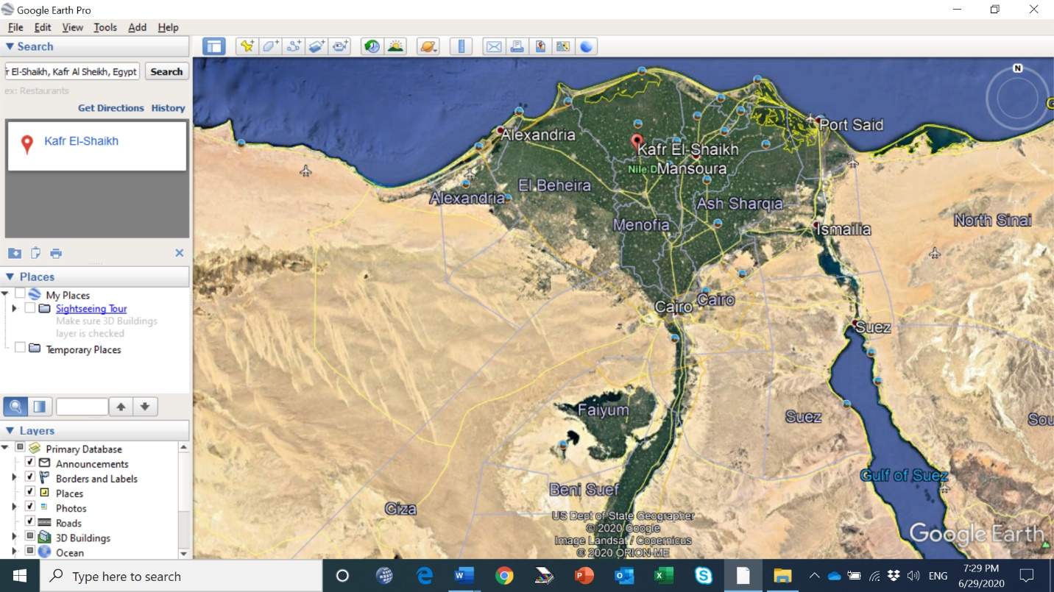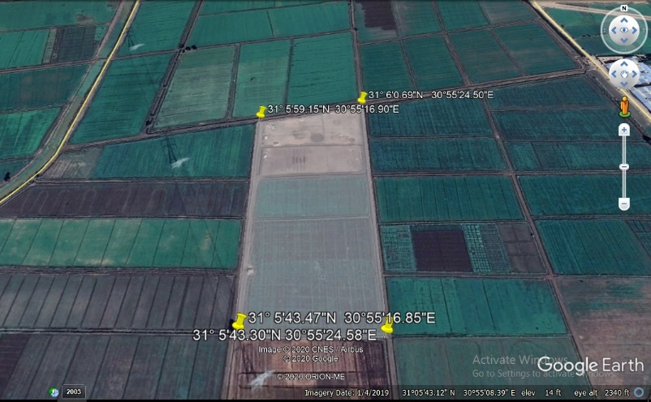

Location of Sakha Agricultural Research Station in Nile Delta